**Sentimental Analysis of Tweets using SAP DATA hub**

1. Build one graph and use Twitter operator to extract the tweets into SAP DATA HUB environment. In this use case I am extracting Data with hashtag”India” from twitter. Below is the output format after extraction:

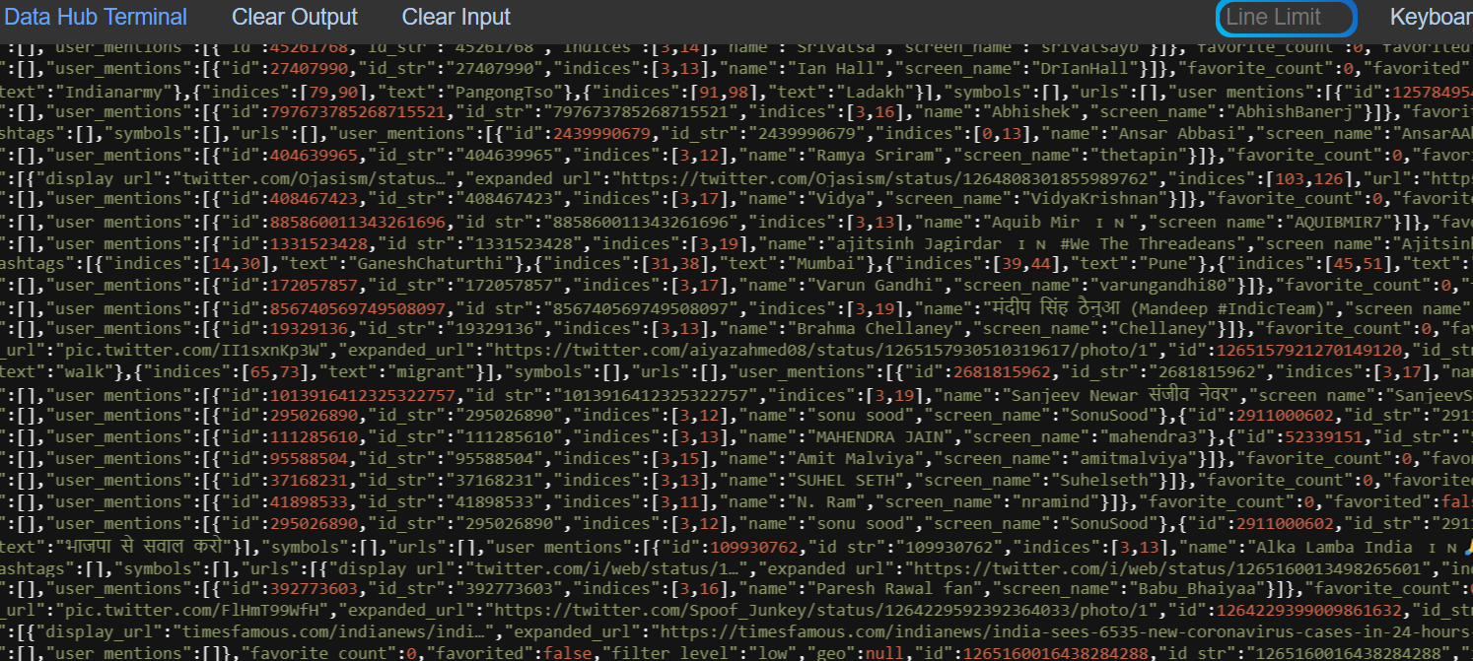

1. You can remove the header from the output in order to read the tweets . Using below python scipt we can convert the tweets into readable format.

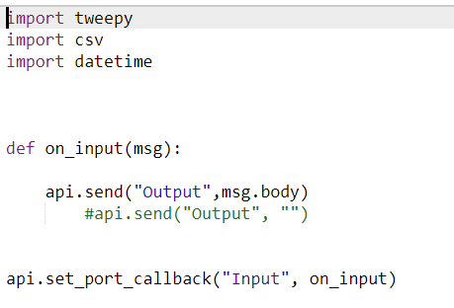

After removing Head outputs will look like :

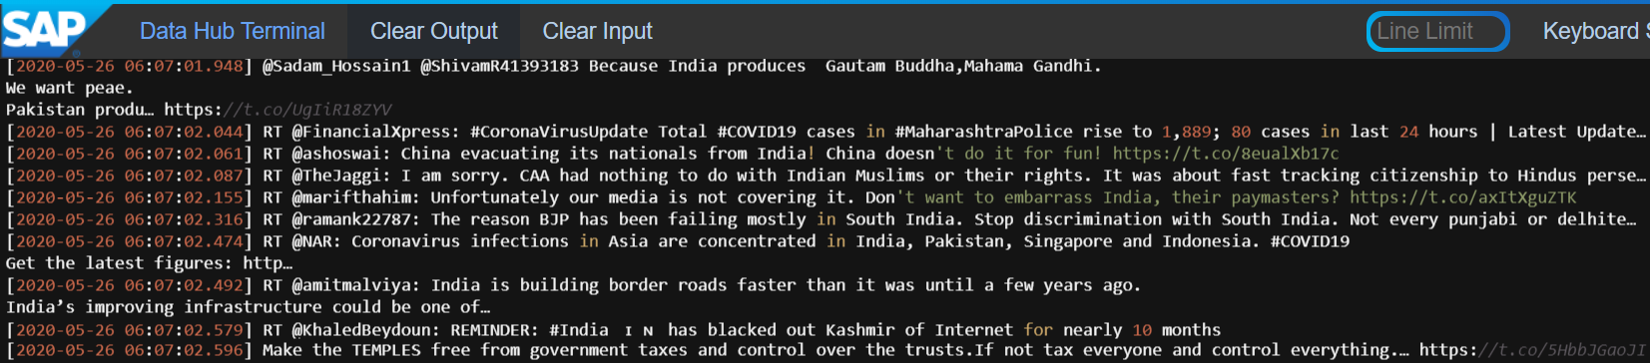

1. Now use sentiment analysis operator to calculate the polarity of every tweets . Operator has standard library which will return the polarity on basis of words used in tweets. Below is the script used in Sentiment Operator:

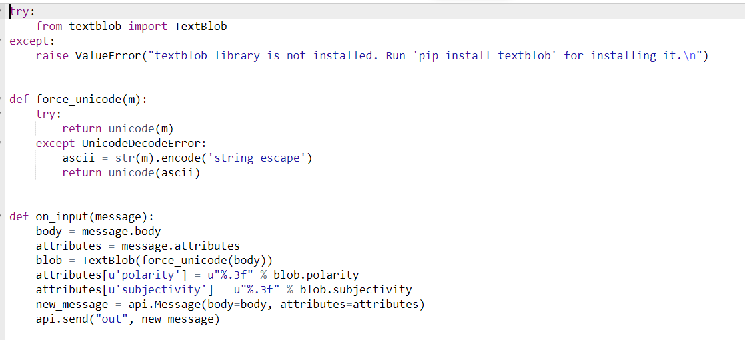

1. In current scenario I have data for India extracted from twitter, now I will segregate this data into three dimension i.e
2. Covid-19
3. Economy
4. Lockdown

Using python code we can identify the above words used in tweets related to India and using sentiment analysis operator I will get the polarity of the tweets like 0.0120,0.000 or – 0.0123

I have categorized sentiments into three types- Positive ( If Polarity is positive,Negative if polarity is less than 0 and Neutral if polarity is equal to 0)

Below is python code I have written to calculate the sentiments of COVID-19 related to India and convert it into CSV format .

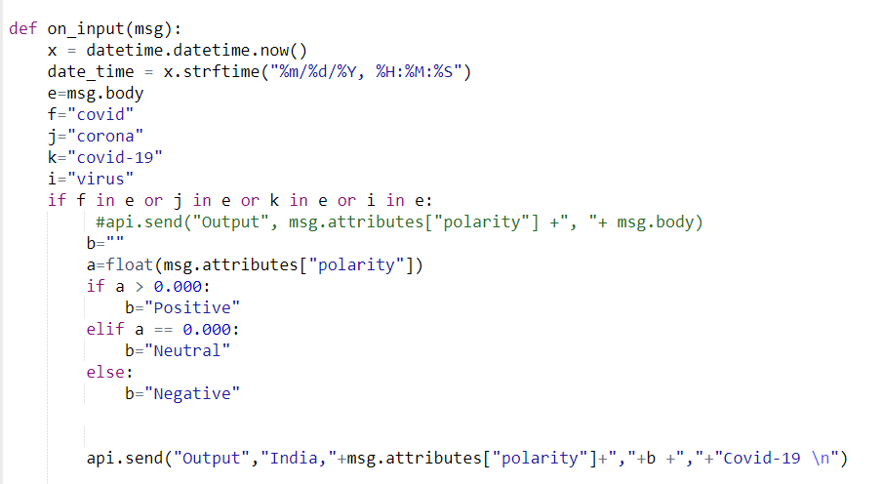

Output will be is CSV format :

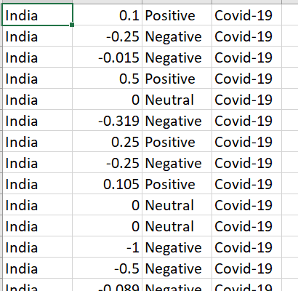

1. Similarly we can write another python code to calculate sentiments on economy and lockdown and will get the output in CSV format as above.

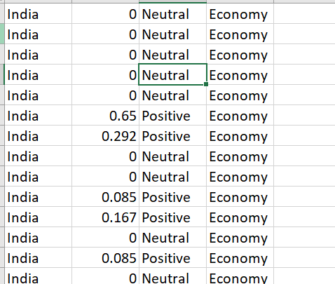

1. Then we can merge all three output in one single CSV file . We can also load the data in SAP Vora tables from CSV file. After completing all the steps ,graph will look like as below:

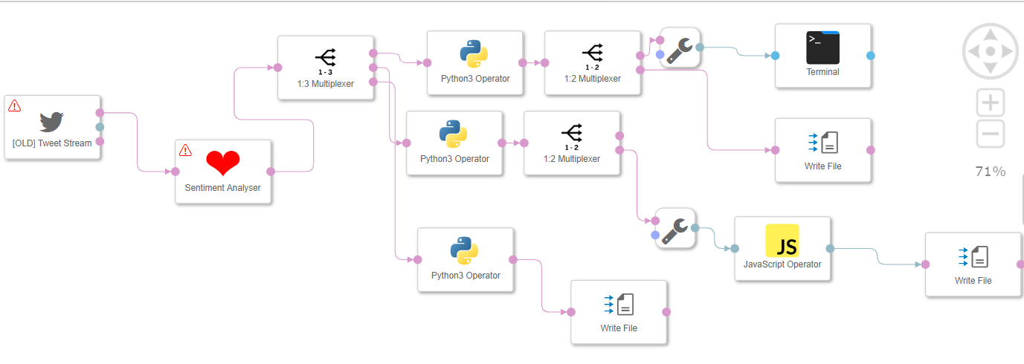

Below is the new graph to merge the records into one target output:

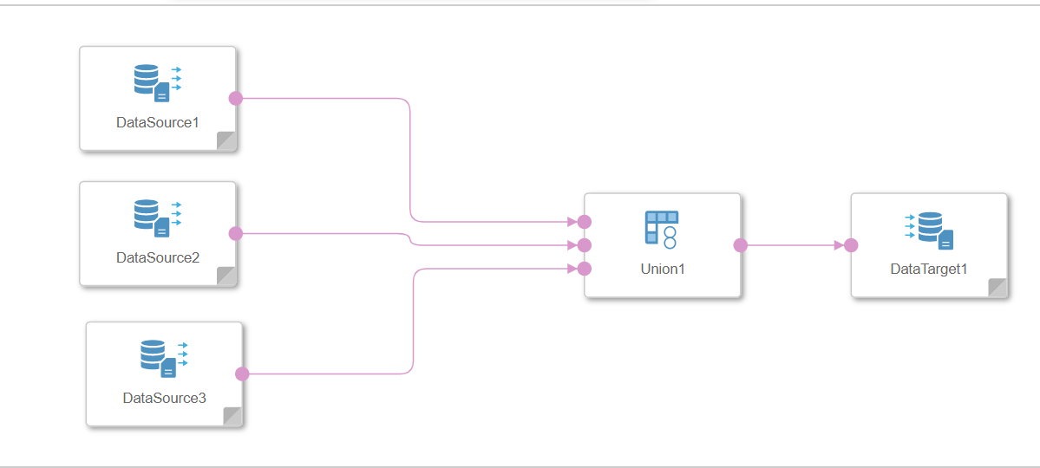

1. We can use CSV file as source to create dashboards/reports etc like below: Here I have used opensource dashboard tool to build sample dashboard:

